Eclipse Mobile Tools for Java Platform
Implementation Overview
DRAFT 0.1.5
Document Status: Draft
Last Modified: 16.02.2006

1 Document Control Information 4
1.1 Change History 4
1.2 Approval Distribution 4
1.3 Document Availability 5
1.4 Document Contributors 5
2 About This Document 6
2.1 Purpose 6
2.2 Intended Audience 6
2.3 Related Documentation 6
2.4 Additional Reference Material 6
2.5 Terminology 6
3 Implementation Description 7
3.1 Overview 7
3.2 MTJ Core Model 9
3.2.1 Enumerations 9
3.2.2 Device Platform, Device and Runtime Platform Definition 10
3.2.3 Device Description 11
3.2.4 Project 12
3.3 MTJ Frameworks and extension points 14
3.3.1 Device Management 14
3.3.2 Build Management 16
3.3.3 GUI Builder Management 16
3.3.4 Deployment Management 16
3.3.5 Security Management 16
3.3.6 Build Provider 16
3.3.7 Device Platform Provider 16
3.3.8 Device Description Provider 17
3.3.9 GUI Builder Provider 17
3.3.10 Screen Engine Provider 17
3.3.11 Admin GUI Provider 17
3.3.12 Preprocessing Provider 17
3.3.13 Obfuscation Provider 18
3.3.14 Packaging Provider 18
3.3.15 Signing Provider 18
3.3.16 Deployment Provider 18
3.4 Core Implementation Structure 19
3.4.1 Core Plug-ins 19
3.4.2 MTJ Development IDE Plug-in 20
3.4.3 MTJ extension Plug-ins 21
4 Cvs Structure 23
4.1 Overview 23
4.2 Plugins -folder 23
4.3 Extension Templates -folder 23
4.4 Releases -folder 23
5 Mtj Extensions Development 24
5.1 Checking Out the Source Code 24
5.2 Setting up the Target Platform 26
5.3 Running Your EclipseApplication 28
5.4 Persisting Own Changes 29
6 Issues 30
6.1 Issue 1 30

Document Control Information
The following are members of the approval/review team for this document. The document owner is responsible for carrying out the approval process. This document will be distributed to the approvers/reviewers along with a deadline for feedback; the document will be revised based on the feedback and resubmitted for a final review. Please send all “Issues/Concerns”, “Approvals” and other comments on this document to Arto Laurila (mailto:arto.laurila@nokia.com).

This document will reside in the CVS repository and on the Eclipse MTJ web page.

Change History

Version | Date | Person | Changes
Initial Draft | 1/11/2006 | JJ. Niekkamaa | Initial creation. Edits will be made under this change listing until first distribution.
1.4 | 1/30/2006 | A. Laurila | Plug-in category naming change.
1.5 | 2/16/2006 | A. Laurila | CVS-repository moved to Eclipse.org

Approval Distribution

Name | Approval Status | Position
Arto Laurila |  | Nokia MTJ Architecture Representative
Kevin Horowitz |  | IBM MTJ Architecture Representative
Craig Setera |  | MTJ Architecture Representative

Document Availability
The latest version of this document is available online at the Eclipse MTJ project web page (put in a hyperlink here).

The responsibility for using the latest level of this document lies with the user of the document. This version of the document is retained online until superseded by a new level.

Document Contributors
The following are thanked by the author(s) for their contribution to this document:

- Arto Laurila – Nokia
- …

About This Document

Purpose
The purpose of this document is to describe the implementation for the Mobile Tools for Java project.

Intended Audience
The audience for this document is intended to be any party wishing to extend the MTJ project either for possible contribution to the project itself, or for product/organization specific extensions to the project (e.g. Company xxyy to support debug and deployment to their specific platform(s))

Related Documentation

Additional Reference Material

Terminology

Implementation Description

Overview

MTJ implementation is modularized by dividing the implementation to different Eclipse plug-ins that is published by MTJ Core plug-in. Also all common MTJ classes are assembled inside the Core Plug-ins. Therefore MTJ functionality implementation component (MTJ Extension) is created as Eclipse Plug-in that extends one or some MTJ extension points and is dependent on the Core Plug-ins.

Core Plug-in is detailed described in section 3.4.1.

MTJ extension points can be divided to three categories by their functionality:
- extendable framework extension points,
- service extension points and
- extended service extension points.

Dependencies between different extension implementations follow basically the three layers that come from the categorization. So e.g. Device Management –extension that belongs to extendable framework extension points –layer uses Device Platform Provider and Device Description Provider –extensions that are service extension points –layer’s implementation.

Extension Points are detailed described in section 3.3.

All the extension point definitions are using MTJ’s common data structures. Implementation of them is based on Eclipse Modeling Framework (EMF).

Data structures are detailed described in section 3.2.

MTJ Core Model

MTJ common data model implementations are done with Eclipse Modeling Framework (EMF). This section just gives overview of the model and detailed Rose –model of it can be found in the Eclipse MTJ’s CVS:

Repository location: /cvsroot/dsdp

And in sub-folder:
org.eclipse.mtj/mtj-home/models

Please see the general Eclipse CVS instructions from: http://wiki.eclipse.org/index.php/CVS_Howto

Enumerations

Valid value-group of different attribute types are defined as enumeration inside the corresponding Java class. Current definitions are:

Device Platform, Device and Runtime Platform Definition

Device Platform contains of one or more Device instances. MTJ plug-in doesn’t know if the Devices are device emulators or real devices because the plug-in extension point API hides all implementation details. Device Platform also consists of Device Platform Configuration. These are the values that are installation –specific and must or could be set by the Device Platform’s user (i.e. emulator’s installation directory).

Device contains of Device Description and Device Configuration. Device Description is described in Device Description Provider –section. Configuration represents those values that are installation –specific. Device has also a Runtime Platform Definition that describes the environment that the device is capable to run on. Runtime Platform consists of Device Configuration, Device Profile, Service APIs and JVM Implementation.

Device Configuration defines used configuration (e.g. CDC or CLDC) and its version. Device Profile defines used profile (e.g. MIDP) and its version. Service APIs are either APIs that are defined in Device Profile or API of optional Services that the Device’s OS is supporting. Runtime Platform Definition is always based on defined JVM Implementation. Service API –object contains the standardize service name and it’s version, e.g. WMA 1.1, MMAPI 1.1 or Location API 1.0. Service API has also reference to JAR Library that implements the API. Also Device Configuration has reference to JAR Library that implements the functions. Also JVM Impl –object contains the JVM name and its version.

Device Description

Device Description shows basic capabilities of devices. Every Device Description instance represents one real device and is identified by vendor name and device model. Capabilities could be device configuration, device profiles or services API that are supported by the device. Capabilities could be also e.g. color depth, screen size, canvas size, camera resolution, supported data exchange protocol, heap size, max jar size, operating system, supported video format or supported sound format.

Device Groups are representing a group of devices that have similar capabilities. The groups capabilities are same that the Device Descriptions’. Device Group has also name and description that help to realize the groups devices capabilities.

Project

Mobile Project development is targeted to devices that have certain Device Configuration and Device Profile. Therefore MTJ’s Project has also Device Configuration and Device Profile defined.

It’s possible to select a set of Service APIs to the Project. Based on the selected set of APIs corresponding Jar –libraries are added to the project. Project always has default device that matches to the Projects definitions. That default device also gives the needed Jar –libraries to the Project.

Project can select smaller set of APIs that the targeted devices are supporting. By selecting smallest possible set of needed APIs, the number of suitable devices is bigger.
Although the Project has the default device, the Projects definitions can match to several devices.

MTJ Frameworks and extension points

MTJ Core’s defined extension points in layer categories and corresponding Java interfaces are:

MTJ Framework Plug-in Extension Points:
- Device Management org.eclipse.mtj.core.deviceManagement
- GUI Builder Management org.eclipse.mtj. core.guiBuilderManagement
- Build Management org.eclipse.mtj. core.buildManagement
- Security Management org.eclipse.mtj.core.securityManagement
- Deployment Management org.eclipse.mtj. core.deploymentManagement

Eclipse-dependent Plug-in Extension Points:
- Build Provider org.eclipse.mtj. core.buildProvider
- Device Platform Provider org.eclipse.mtj. core.devicePlatformProvider
- Device Description Provider org.eclipse.mtj. core.deviceDescriptionProvider
- GUI Builder Provider org.eclipse.mtj. core.guiBuilderProvider
- Screen Engine Provider org.eclipse.mtj. core.screenEngineProvider
- Admin GUI Provider org.eclipse.mtj. core.adminGuiProvider

Standalone Plug-in Extension Points:
- Preprocessing Provider org.eclipse.mtj. core.preprocessingProvider
- Obfuscation Provider org.eclipse.mtj. core.obfuscationProvider
- Packaging Provider org.eclipse.mtj. core.packagingProvider
- Signing Provider org.eclipse.mtj. core.signingProvider
- Deployment Provider org.eclipse.mtj. core.deploymentProvider

Device Management

Device Management is responsible to offer services to fetch Device Platforms, Devices and Device Descriptions. It combines data from Device Platform Providers, Device Description Providers and Deployment Providers. Implementer of Device Management is publishing the services by Device Management -extension point interface.

The Device Management uses Device Platform and Device Description information.

Device Management’s method getDevices( devicePlatformName ) return all existing devices from the Device Platform which name corresponds the argument value. Control flow of the method implementation in MTJ environment is:
1: Client, who wants to call the method, first get reference to the Device Management implementation by calling MTJ Core’s method getImplementation with argument ”Device Management”.
2: Client calls the Device Management implementation’s getDevices -method.
3: Device Management implementation get reference to the Device Platform implementations by calling MTJ Core’s method getImplementation with argument ”Device Platform”.
4: Device Management implementation selects the Device Platform that corresponds the name that it get as parameter in the original method-call and call that Device Platform’s getDevices -method. The method returns all existing Devices in the DevicePlatform.
5: Device Manager needs to add Device Description info to the Devices data. Therefore it gets reference to the Device Description Provider implementation by calling MTJ Core’s method getImplementation with an argument ”Device Description Provider”.
6: Device Manager get Device Description info to every Device by calling Device Description Provider’s method getDeviceDescription with arguments of different Devices.

Build Management

Build Management is responsible to carry out the build process. Implementer of Build Management is publishing the services by Build Management -extension point interface. Method build functionality is:
- Collect Project –data structure, which is described in the Build Provider section, from the project that is given as parameter.
- Get suitable Build Provider implementation from MTJ
- Calls the Build Provider’s build method.
Build Management is also responsible of automatic builds in Eclipse environment.

GUI Builder Management

GUI Builder is inherited and extended from Eclipse Visual Editor (VE) framework. The base VE framework is enhanced with the mobile features and mobile domain specific screen engines. Each screen engine implementation can extend different mobile vendor specific look & feels and device requirements as also the domain specific UI components and widgets. The VE can be enhanced with the multimedia specific features, e.g. to enable support for OpenGL, SVG-T, etc.

Deployment Management

t.b.a.

Security Management

The Security Management services provide management for the keys and certificates. The Security Management is a global service, i.e. the managed keys and certificates can be used in what ever mobile project.

Build Provider

Build Provider is responsible to the build the project from source to deployment. Build Provider instances can implement the build process differently. Method getSupportedTypes that returns the build types that are supported by the Build Provider.

Device Platform Provider

Target environments are seen as Device Platforms by the MTJ environment. Device Platform’s type could be emulator platform or real device platform. Functionalities, that the Device Platform does implement, are:
- binary code pre-verification and
- application launching.

Device Description Provider

Device Description Provider offers information about devices and groups them by similar capabilities. Functionalities, which the Device Description Provider implements, are:
- Device Description database,
- Matching Device Descriptions query based on a Device Group and
- Management of custom Device Groups.

GUI Builder Provider

The GUI builder is inherited form the Visual Editor project. The base functionality is enhanced with the mobile features e.g. like the multimedia support needs.

Screen Engine Provider

The Screen Engine provider does implement the J2ME specific profile UI layouts and UI components. E.g. the MIDP screen engine provides the LCDUI layouts, look & feel and UI components. Other mobile vendors may extend this approach by providing their own implementations (like Nokia L&F).

Admin GUI Provider

MTJ Development IDE is depending on MTJ Core Plug-in. It also publishes a new extension point Admin GUI Provider that is used to add new functionalities to MTJ Development IDE. All MTJ extension point implementers, like Device Platform Provider, that need Administration GUIs, must do it by implementing the Admin GUI Provider extension point.

Preprocessing Provider

Preprocessing is used to solve device fragmentation problem in source code level. Preprocessing Provider implements functionality that is used to modify source code to match target devices. Method process switches the code blocks on, that follows the given processing conditions, and switches off other ones.
It also implements functionality that is used to get code template for a given processing condition.

Obfuscation Provider

Obfuscation Provider is used to obfuscate source code.

Packaging Provider

Packaging Provider is responsible of creating deployment packages from application projects resources. Realization of the result Deployment object depends on the parameter type. Also resource objects are depending on the type. Deployment Creator implementer's method getSupportedTypes that returns the deployment types that are supported by itself. Created deployments are created to folder that is defined by targetFolder attribute. I.e. MIDlet project deployment consists of Application JAR and JAD files.

Signing Provider

Signing Provider is responsible to sign project’s different Deployment packages.

Deployment Provider

Deployment Provider is responsible to deploy resources to target Device.

Core Implementation Structure

Core Plug-ins

The MTJ Core Plug-ins are:
- MTJ Core Model,
- MTJ Core and
- MTJ Core Ui.

Dependences between the core plug-ins are show in the picture above:

MTJ Core Model -plug-in

Implementation of the MTJ’s core data structure of EMF is packaged to the MTJ Core Model –plug-in.

Plug-in’s Eclipse id is org.eclipse.mtj.core.model.

MTJ Core –plug-in

The MTJ Core Plug-In is the main plug-in that is tied to the Eclipse workbench. It holds all the MTJ extension point interfaces and core model classes except those that are defined by MTJ’s EMF model. It has a wide set of methods to find, initialize and access to all MTJ main services. The definition set of active extension point can be applied through the MTJ Core plug-in interface. The actual business logic is not written in the MTJ Core plug-in, but it is implemented in a separate service plug-in that extends the MTJ Core plug-in extension point.

The MTJ Core Plug-In has a wide set of methods to find, initialize and access to all MTJ main services. MTJ main services introduce each Eclipse extension points, which interface is implemented in the service extension.

The MTJ Core Plug-In has functionality that makes it possible to mark existing MTJ extension point implementation to active or passive. So with the MTJ functions it’s possible to choose, what plug-ins are in use, in the case that there are several implementations existing in the MTJ Eclipse workspace.

MTJ Core Plug-in’s functionalities are published by MtjServices interface. E.g. to get the active Build Provider –plug-ins can be done with the code:

MtjExtension[] list =
MtjServices.getInstance().getImplementations(
ExtensionType.BUILD_PROVIDER, null, null);

Plug-in’s Eclipse id is org.eclipse.mtj.core..

MTJ Core Ui -plug-in

MTJ Core Ui -plug-in implements admin GUI that makes it possible to choose which extension point implementations are used by the MTJ in the case that are several implementation of the extension point.

The Plug-in’s Eclipse id is org.eclipse.mtj.core.ui.

MTJ Development IDE Plug-in

MTJ Development IDE -plug-in implements all the Eclipse
- Mtj perspective,
- Mtj nature,
- Mtj views,
- Mtj editors and
- Mtj wizards
Those are used to develop Mobile applications in Eclipse MTJ environment.

Plug-in’s Eclipse id is org.eclipse.mtj.ide.

MTJ extension Plug-ins

MTJ extension point implementation plug-ins must be dependent on MTJ Core Model and MTJ Core –plug-in to get the common classes and functionalities of MTJ.

MTJ extension –plug-ins should also be at least dependent on
- org.eclipse.core.runtime,
- org.eclipse.core.resources and
- org.eclipse.emf.ecore
plug-ins.

The plug-ins Eclipse ids are

- Device Management org.eclipse.mtj.extension.devmgmt
- GUI Builder Management org.eclipse.mtj.extension.gbmgmt
- Build Management org.eclipse.mtj.extension.bmgmt
- Security Management org.eclipse.mtj.extension.smgmt
- Deployment Management org.eclipse.mtj.extension.depmgmt
- Build Provider org.eclipse.mtj.extension.bp
- Device Platform Provider org.eclipse.mtj.extension.dpp
- Device Description Provider org.eclipse.mtj.extension.ddp
- GUI Builder Provider org.eclipse.mtj.extension.gbp
- Screen Engine Provider org.eclipse.mtj.extension.sep
- Preprocessing Provider org.eclipse.mtj.extension.prep
- Obfuscation Provider org.eclipse.mtj.extension.op
- Packaging Provider org.eclipse.mtj.extension.pkgp
- Signing Provider org.eclipse.mtj.extension.sp
- Deployment Provider org.eclipse.mtj.extension.depp

Implementation package structures follow the same structure.

CSV Structure

Overview

MTJ CVS root is named as org.eclipse.mtj and it can be checked out with manual command:

cvs -d :pserver;username=anonymous;hostname=dev.eclipse.org:/cvsroot/dsdp checkout org.eclipse.mtj
It contains folders plug-ins, extension templates and releases.

Or by creating CVS-repository in Eclipse:
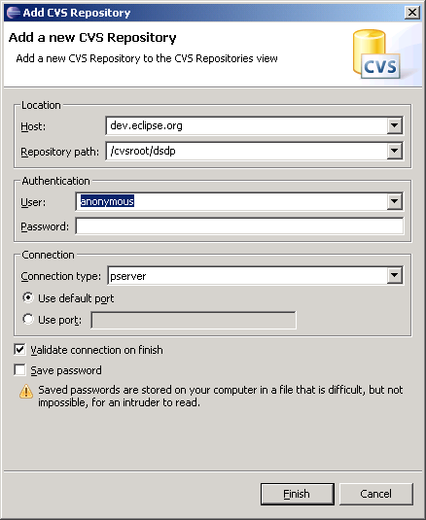

Plug-ins -folder

Plug-ins –folder contains all the existing MTJ plug-in –implementations in their own folders. Folder org.eclipse.mtj contains Eclipse–feature –project and others are Eclipse plug-in –projects.

Extension Templates -folder

Folder extension templates contain ready-made starting points for extension development. See section 5 how to use the templates in the extension development.

Releases -folder

Folder releases contains development versions of the MTJ plug-ins.
[to-do this will be described later]

MTJ Extensions Development

This tutorial shows you how to set up your Eclipse environment to develop or modify the MTJ project plug-ins. First we will discuss how to connect to the CVS repository to check out the MTJ source code. We will then set up our target platform. Next we will make a modification to the MTJ source and run our eclipse application.

Checking Out the Source Code

The normal developer case
1. Access the source code for the Eclipse MTJ from the Concurrent Versions System (CVS) repository. To access the CVS repository select Window > Open Perspective > Other and select CVS Repository Exploring.
2. The CVS Repositories view is now visible in your Eclipse workbench. Select the Add CVS Repository icon (or press right button -> New) and in the Add CVS repository dialog enter the following values:

Host: | dev.eclipse.org
Repository path: | /cvsroot/dsdp
Connection type: | pserver
UID & PW: | Valid user id and no password (empty)

And select finish.

MTJ sub-folder is /org.eclipse.mtj

(These guides apply to normal networking environment. If you are having extra firewalls etc. networking services, they may prevent you to access the Eclipse site. In such case, please read the following: http://wiki.eclipse.org/index.php/CVS_Howto and contact your network support.)

3. The available repositories are shown e.g. when you import project from the CVS
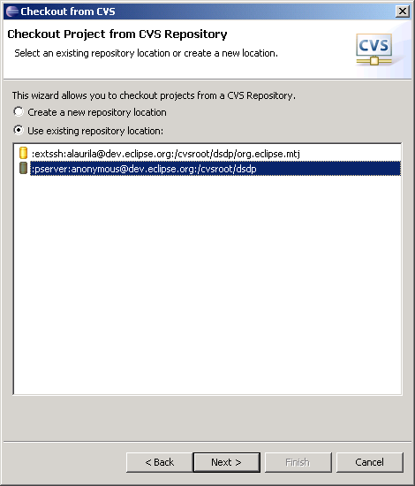
Select Next

4. Select the org.eclipse.mtj sub-folder from this folder view
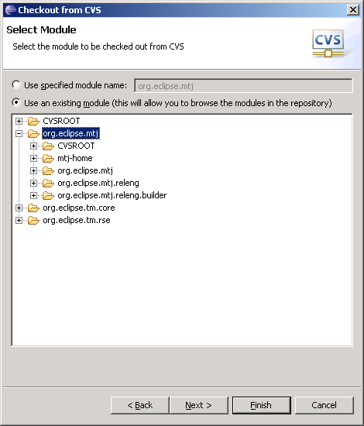

There are visible two other sub-folders that are related to the DSDP main project, please do not use those.

5. Navigate through the folders and find the plug-ins that you are interested in having the source for. The most recent code is in HEAD. The MTJ plug-ins are found in the org.eclipse.mtj folder. For this example we will modify org.eclipse.mtj/plugins/org.eclipse.mtj.extension.dpp.
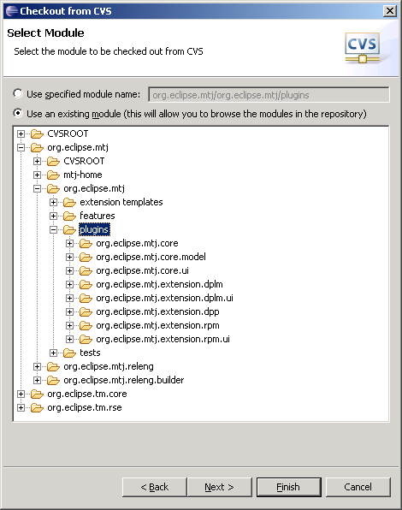

6. Add the project into your local workspace by right clicking on that plug-in and selecting "Check Out".

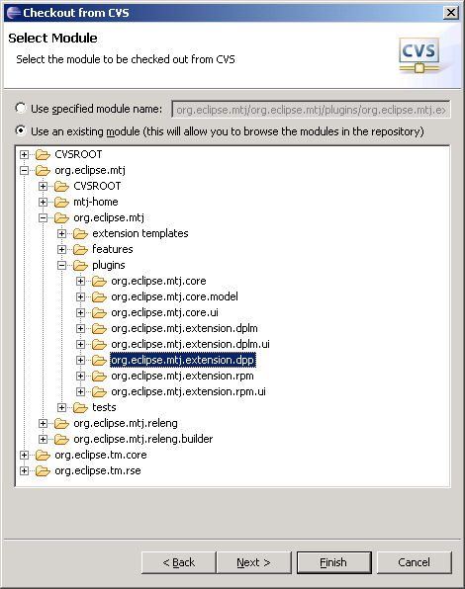

5. Switch back to the Java perspective. The source code for the plug-in you downloaded is now in your workspace.

The committer case

The CVS repository access is similar to the normal developers case, but the connection type is using SSH and the Committer has to have valid Committer user-id and password issued by Eclipse.

Host: | dev.eclipse.org
Repository path: | /cvsroot/dsdp
Connection type: | Extssh (normal port)
UID & PW: | Valid user id and password

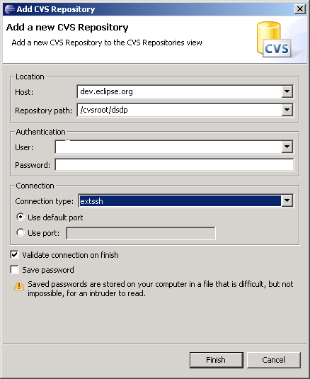

Setting up the Target Platform

The target platform specified contains the eclipse plug-ins which your code will be compiled against. Having a target platform allows you to compile and run your modified code without having to bring all of the source code into your development workbench. The target platform should be the same platform you are developing for.

To set up your target platform:

1. Download and install the desired Eclipse and MTJ versions in a separate folder from your current development Eclipse platform. Ensure that this new platform runs. This will be your target platform.

Download the Eclipse 3.1 platform from Eclipse download proxy.

[To-do, define plug-in versions]

Nr | Plug-in name | Version
1 | Eclipse core | 3.1.1
2
3
4
5
6
7

Running Your Eclipse Application

1. In the Java perspective from the menu bar select Run > Run.

2. In the Run dialog select the Eclipse Application option, then select new.

3. Enter the location of the desired workspace, and select Run.

When this version of Eclipse is run it compiles the source code in your workspace, and runs from your target platform. A second instance of Eclipse is now running and you are now able to test any code modifications you have made.

Persisting Own Changes

To be able to contribute to the Eclipse CVS, you must be a valid, approved committer in MTJ project.

To contribute an enhancement to MTJ, you can commit your code changes to cvs repository. In the Package Explorer view, right click on the modified plug-in project and select first

Team > Synchronize with Repository

If you have changed any source code, select first

Team > Update

To check that has somebody else changed anything in the cvs repository and then

Team > Commit

After that you should select again

Team > Update

(for to get verification of the latest situation in the cvs.)

Issues
The following are known issues and their status.

State: The current state of the issue. Possible values:
- Open
- Resolved <mm/dd/yyyy>
- Deferred
Date Opened: The date this issue was created.
Description: Complete details clearly defining the issue.
Action plan: An account of what steps are being take to resolve this issue.

Issue 1

State: Open
Date Opened: xx/yy/zz
Description: The issue
Action plan: Resolve it.

